It’s going to be a great year!

First Grade

Remote Learning
Handbook

How Remote Learning Will Work

- Each student has been given an SAU56 email account and password. These will be used to sign your child in to their Google account.

- We will use Google Meets for daily whole-class and small group meetings. Students will participate in a morning and afternoon class meeting each day, and 2-3 small group meetings throughout the week.

- Each day, students will receive videotaped lessons in Reading, Writing, Math, Phonics, and Science/Social Studies. The children will watch each lesson, then complete a follow-up activity, which will be submitted to their classroom teacher. These lessons and activities will be accessed through Google Classroom.

- Your child will receive a toolkit containing supplies they will need to participate in online learning and complete the lessons. To make sure that things don’t get lost or damaged, please be sure to keep the toolkit in a safe place and allow your child to use the supplies only when working on school activities.

- As we get to know the children and their needs better, we will form small groups to provide online instruction that is targeted to children’s individual learning styles and academic levels. These will either supplement or replace some of the Google Classroom lessons.

- Families of students who receive Special Education or Title 1 services will be contacted by the service providers to schedule the services.

Be sure to check out the last page of this document for tips on how to prepare for a successful remote learning experience!

Daily Schedule
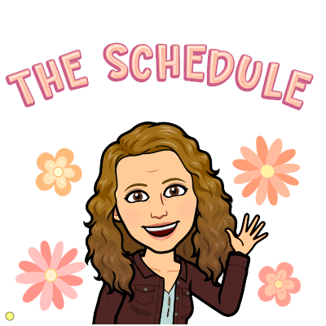

This is a proposed daily schedule. The items in red are times that all children are asked to participate in live, online learning. Other times will be used for small-group online instruction, or for your child to work on the Google Classroom lessons, as well as to have snack, movement, and free-choice breaks. We understand that the schedule will not work for all families, however, and we encourage you to create a schedule that works for you and your child.

8:55-9:30 Independent Learning/Small Group Meetings
9:30-10:00 Class Morning Meeting
10:00-11:30 Independent Learning/Small Group Meetings
11:30-12 Lunch
12:00-1:00 Independent Learning/Small Group Meetings
1:00-1:30 Class Afternoon Meeting
1:30-2:00 Snack/Break
2:00-2:45 Special (Gym, Music, Art, Library, Health)
*Specials will begin on Friday, September 4th
2:45-3:15 Independent Learning/Small Group Meetings

What to Expect In The First Week

We will begin the year with lots of activities designed to help students and families feel comfortable using the Google apps. We will start with just a couple of lessons each day, then gradually increase the number of lessons as children become accustomed to the schedule.

Goals for Week 1
- Make sure that everyone is signed up for Google Classroom and children are attending the daily whole-class meetings.

- Teach children how to use the “mute” button so that the microphone is on when it is their turn to speak and off when it is not.

- Increase children’s comfort with speaking during class meetings by doing daily greetings and other fun activities.

- Teach and practice expectations for safe, respectful, responsible behaviors during online meetings.

- Hold small-group meetings in which children will play games to help them get to know one another and build classroom community.

- Introduce Google classroom and teach children how to access and complete assignments.

**Specials will begin on Friday, September 4th.

Contact Information

Please feel free to contact me at any time with questions or concerns you may have, or to share good news about your child!

Class DoJo:
I use “Class DoJo” to help keep you informed about important classroom news.
DoJo is a free service that allows you to get messages from me directly to your computer or mobile device and allows you to send messages to me.

Joining our class on DoJo is easy. If you haven’t already signed up, please use the link in the email to sign up now!
Phone: 692-2435
Email:Jodie Corbeil jcorbeil@sau56.org
Carol Foley kfoley@sau56.org
Marisa Henderson mhenderson@sau56.org
Jen Hickey jhickey@sau56.org
Alicia Parks aparks@sau56.org
Kylie Perkins kperkins@sau56.org

Tips for Successful Remote Learning
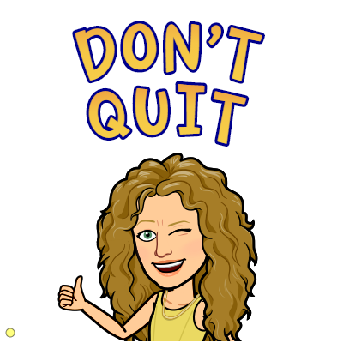
Overcoming Obstacles…
- Let your child make choices, such as deciding what order to do the video lessons in.
- Use an incentive system, such as allowing your child to earn a sticker or tally mark for
completing lessons, then redeeming the “points” for a reward such as family fun time or
extra choice time on Friday.
- Communicate frequently with your child’s teacher so that we can problem-solve
together. We’ve got this!!

Create a designated learning spot for your child to participate in online instruction and do schoolwork.
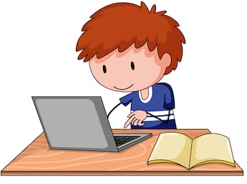
- Choose a quiet space without a lot of background noise.
- Situate your child away from toys, television, and other distractions.
- Keep your child’s remote learning toolkit in the learning spot. Help your child learn to put all the materials back into the toolbox when finished and do not allow the materials to be used other than for schoolwork.

Come up with a daily schedule and try to stick to it.
- Include online instruction times as well as times for your child to
work on the daily video lessons.
- Provide time for movement breaks, snacks, and free choice.
- A good rule of thumb for first grade is about 20-30 minutes of
focused work time followed by 5-10 minutes of time for a
movement break.
- Create a visual of the schedule and post it where your child can
see it, then refer to it throughout the day so your child
understands the structure of the day.

Make the most of online learning times.
- If possible, have your child use headphones or earbuds with a built-in microphone. This eliminates background noise, helps your child to hear others, and helps others to hear your child. These can be purchased very inexpensively at Wal-Mart, Target, Best Buy, etc.
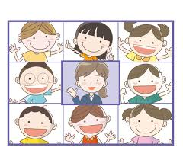
- While using Google Meets, use the “Grid View” so that your child can see and interact with all of the participants.
- Once your child is comfortable using the technology, it is not necessary for an adult to sit with the child the entire time, however it is helpful to have an adult nearby to help with technology issues if they arise and to monitor behavior.
- Help your child to understand that, just as we would not have toys or snacks while learning at school, we should not have them while learning online.

