See what kinds of things you can find or see that make the letter X!
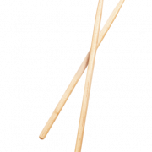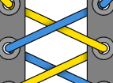
List or draw 5 things that you used or saw shaped like the letter X!!
1.

2.

3.

4.

5.

