Following directions and increasing vocabulary
Yak 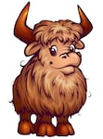 Yolk 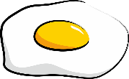 Yarn 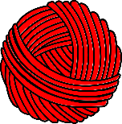
Yacht Yo-yo 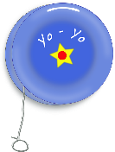 Yam 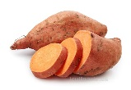

- Using the Y page with pictures in it, review the words that begin with the Y sound to make sure your child knows what each picture is.
  - Where is the picture of the Yak? What other animal does it look like (cow, buffalo, bull,etc.)
  - What is the middle of an egg called? (the yolk) What color is it? (yellow)
  - What is a yam? (it’s a kind of potato that tastes sweet) Is it a fruit or a vegetable? (it’s a vegetable) What color is a yam? (orange)
  - Can you find the yarn? What can you do with yarn? What is made of yarn?
  - Do you know what a yacht is? (a very big, fancy boat)
  - Where is the yo-yo? What is it? (a toy with a string you use to move it up and down)
- Give directions one at a time to follow:
  - Color the yarn blue
  - Color the yak brown
  - Color the yolk yellow
  - Color the yam orange, etc. (until all pictures are completed)

